1. **Student**

INSERT INTO `student`(`First_Name`, `Middle_Name`, `Last_Name`, `Email_ID`, `S_ID`, `Age`, `Contact_Number`, `Event_Name`, `PG_Name`, `Re_Name`, `University_Name`, `Degree`, `Branch`, `Sem`) VALUES ('Dishant','H','Modh','dishant@gmail.com','1', 18, 9512100731,'BreakUp Day','Royal Care','Prime Dinning Hall','Dharmsinh Desai','B.Tech','IT',5,’Male’ );

INSERT INTO `student`VALUES ('Twiency','','Korat','trkorat76@gmail.com','2', 18, 9428666531,'Coding war','Blossom','Hotel Vandan','IIT-Gandhinagar','B.Tech','CSE',5,'Female');

INSERT INTO `student`VALUES ('Divyesh','D','Chotaliya','dc2310@gmail.com','3', 17, 6356275041,'Cycle Marathon','Shakti','Law Canteen','Nirma','B.Tech','CS',7,'Male' );

INSERT INTO `student` VALUES ('Jay','','Panchal','jaypanchal@gmail.com','4', 22, 9586986565,'Falicific','Aarav Hostel','Panihari restaurant','GMIT','B.Tech','IT',1 ,'Male');

INSERT INTO `student`VALUES ('Shivani','K','Modi','shivanimodi@gmail.com','5', 19, 7889455622,'Photography','Samaras','Virat fast-food','DaIICT','B.Tech','ICT',3,'Female' );

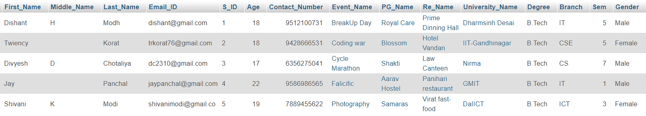

1. **University**

INSERT INTO `university`(`University_Name`, `Location`) VALUES ('Dharmsinh Desai', 'Nadiad');

INSERT INTO `university`(`University_Name`, `Location`) VALUES ('GMIT', 'Survey No.30, Sidsar Road, near Iscon Eleven, Bhavnagar');

INSERT INTO `university`(`University_Name`, `Location`) VALUES ('DaIICT', 'near, DAIICT-campus, Reliance Cross Rd, Gandhinagar');

INSERT INTO `university`(`University_Name`, `Location`) VALUES ('Nirma', 'Sarkhej - Gandhinagar Hwy, Gota, Ahmedabad');

INSERT INTO `university`(`University_Name`, `Location`) VALUES ('IIT-Gandhinagar', ' Indian Institute of Technology, Palaj');

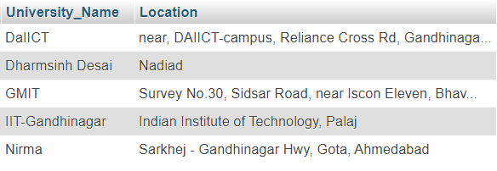

1. **Courses**

INSERT INTO `courses`(`University_Name`, `Courses_Name`) VALUES ('DaIICT','ICT');

INSERT INTO `courses`(`University_Name`, `Courses_Name`) VALUES ('DaIICT','ICT-CS');

INSERT INTO `courses`(`University_Name`, `Courses_Name`) VALUES ('DaIICT','MnC');

INSERT INTO `courses`(`University_Name`, `Courses_Name`) VALUES ('Dharmsinh Desai','CH');

INSERT INTO `courses`(`University_Name`, `Courses_Name`) VALUES ('Dharmsinh Desai','CE');

INSERT INTO `courses`(`University_Name`, `Courses_Name`) VALUES ('Dharmsinh Desai','IT');

INSERT INTO `courses`(`University_Name`, `Courses_Name`) VALUES ('Dharmsinh Desai','MH');

INSERT INTO `courses`(`University_Name`, `Courses_Name`) VALUES ('Dharmsinh Desai','EC');

INSERT INTO `courses`(`University_Name`, `Courses_Name`) VALUES ('Dharmsinh Desai','IC');

INSERT INTO `courses`(`University_Name`, `Courses_Name`) VALUES ('Dharmsinh Desai','Civil');

INSERT INTO `courses`(`University_Name`, `Courses_Name`) VALUES ('Dharmsinh Desai','BCA');

INSERT INTO `courses`(`University_Name`, `Courses_Name`) VALUES ('Dharmsinh Desai','MBA');

INSERT INTO `courses`(`University_Name`, `Courses_Name`) VALUES ('Dharmsinh Desai','MCA');

INSERT INTO `courses`(`University_Name`, `Courses_Name`) VALUES ('Dharmsinh Desai','BDS');

INSERT INTO `courses`(`University_Name`, `Courses_Name`) VALUES ('Dharmsinh Desai','MBBS');

INSERT INTO `courses`(`University_Name`, `Courses_Name`) VALUES ('Nirma','CS');

INSERT INTO `courses`(`University_Name`, `Courses_Name`) VALUES ('Nirma','EC');

INSERT INTO `courses`(`University_Name`, `Courses_Name`) VALUES ('Nirma','CH');

INSERT INTO `courses`(`University_Name`, `Courses_Name`) VALUES ('GMIT','CE');

INSERT INTO `courses`(`University_Name`, `Courses_Name`) VALUES ('GMIT','IT');

INSERT INTO `courses`(`University_Name`, `Courses_Name`) VALUES ('GMIT','Civil');

INSERT INTO `courses`(`University_Name`, `Courses_Name`) VALUES ('IIT-Gandhinagar','CSE');

INSERT INTO `courses`(`University_Name`, `Courses_Name`) VALUES ('IIT-Gandhinagar','CH');

INSERT INTO `courses`(`University_Name`, `Courses_Name`) VALUES ('IIT-Gandhinagar','Civil');

INSERT INTO `courses`(`University_Name`, `Courses_Name`) VALUES ('IIT-Gandhinagar','Biological Engg.');

INSERT INTO `courses`(`University_Name`, `Courses_Name`) VALUES ('IIT-Gandhinagar','MH');

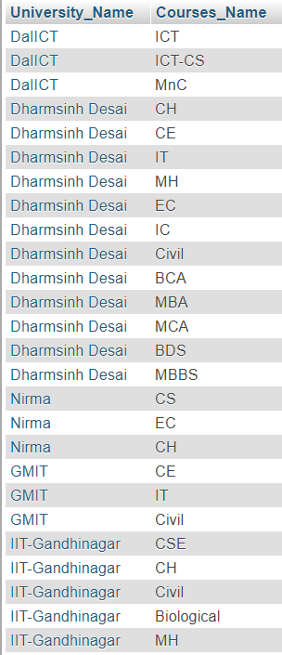

1. **STATIONARY**

INSERT INTO `stationary`(`Timmings`, `Stationary_Name`, `Stationary_Address`) VALUES ('09:00:00','Samir','Shivalik Building, 1, Atabhai Rd, Bhavnagar');

INSERT INTO `stationary`(`Timmings`, `Stationary_Name`, `Stationary_Address`) VALUES ('11:00:00','Mahajan','Nirma University, Ahmedabad');

INSERT INTO `stationary`(`Timmings`, `Stationary_Name`, `Stationary_Address`) VALUES ('09:00:00','Vidhyarthi','Shop No.1653, Shopping Center, Sector-3/A, Sector 3, Gandhinagar');

INSERT INTO `stationary`(`Timmings`, `Stationary_Name`, `Stationary_Address`) VALUES ('10:00:00','Jay Book ',' Sector 11, Gandhinagar');

INSERT INTO `stationary`(`Timmings`, `Stationary_Name`, `Stationary_Address`) VALUES ('09:00:00','Student Book','13/14, Chanakya Complex, Vania Vad, Nairobi Colony, Nadiad');

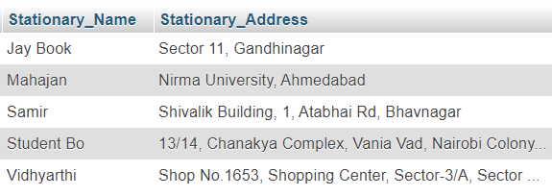

1. **Events**

INSERT INTO `events`(`Event_Date_Start`, `Event_Date_End`, `Event_Name`, `Branch`) VALUES ('2019-12-09 10:00:00','2019-12-09 22:00:00','Cycle Marathon','All');

INSERT INTO `events`(`Event_Date_Start`, `Event_Date_End`, `Event_Name`, `Branch`) VALUES ('2020-01-26 07:00:00','2020-01-27 18:00:00','Photography','All');

INSERT INTO `events`(`Event_Date_Start`, `Event_Date_End`, `Event_Name`, `Branch`) VALUES ('2020-02-14 10:00:00','2020-02-15 22:00:00','BreakUp Day','All');

INSERT INTO `events`(`Event_Date_Start`, `Event_Date_End`, `Event_Name`, `Branch`) VALUES ('2020-03-07 18:00:00','2020-03-17 23:00:00','Falicific','All');

INSERT INTO `events`(`Event_Date_Start`, `Event_Date_End`, `Event_Name`, `Branch`) VALUES ('2020-03-18 10:00:00','2020-03-20 22:00:00','Coding war','IT');

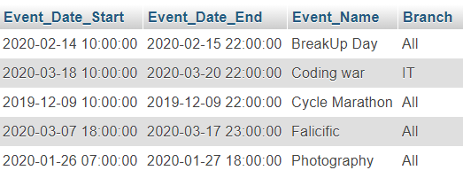

1. **BOOK**

INSERT INTO `book`(`Book_Name`, `Book_ID`, `Author_Name`, `Buy_Date`, `New_Old`) VALUES ('ANSI C', 1 , 'E Balaguruswami', '2020-07-01', 'New');

INSERT INTO `book`(`Book_Name`, `Book_ID`, `Author_Name`, `Buy_Date`, `New_Old`) VALUES ('DDC', 2 , 'Morris Manno', '2019-06-26', 'Old');

INSERT INTO `book`(`Book_Name`, `Book_ID`, `Author_Name`, `Buy_Date`, `New_Old`) VALUES ('DAA', 3 , 'Cormen', '2020-08-05','Old');

INSERT INTO `book`(`Book_Name`, `Book_ID`, `Author_Name`, `Buy_Date`, `New_Old`) VALUES ('VILE BODIES', 4 , 'EVELYN WAUGH', '2020-02-01', 'New');

INSERT INTO `book`(`Book_Name`, `Book_ID`, `Author_Name`, `Buy_Date`, `New_Old`) VALUES ('PALE FIRE', 5 , 'VLADIMIR NABOKOV', '2020-12-31', 'New');

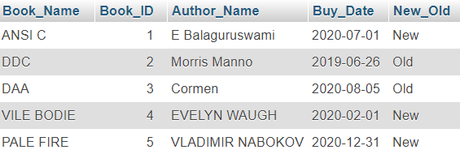

1. **Restaurant**

INSERT INTO `resturant`(`Re_Address`, `Re_Name`, `Re_Timing_Start`, `Re_Timing_End`, `Star`, `B_L_D`) VALUES ('Ground Floor, Prime Square,Opp. Amba Ashram,Uttarsanda Road, near DDIT College, Nadiad','Prime Dinning Hall','10:30:00','22:00:00', 4, 'All');

INSERT INTO `resturant`(`Re_Address`, `Re_Name`, `Re_Timing_Start`, `Re_Timing_End`, `Star`, `B_L_D`) VALUES ('DA IICT Rd, Infocity, Gandhinagar','Virat fast-food','10:00:00','23:00:00', 4 , 'All');

INSERT INTO `resturant`(`Re_Address`, `Re_Name`, `Re_Timing_Start`, `Re_Timing_End`, `Star`, `B_L_D`) VALUES ('Diversion Rd, Gandhinagar','Hotel Vandan','11:00:00','23:30:00', 3, 'All');

INSERT INTO `resturant`(`Re_Address`, `Re_Name`, `Re_Timing_Start`, `Re_Timing_End`, `Star`, `B_L_D`) VALUES ('Nirma University, Nirma University Rd, Ahmedabad','Law Canteen','08:00:00','20:00:00', 4.5, 'All');

INSERT INTO `resturant`(`Re_Address`, `Re_Name`, `Re_Timing_Start`, `Re_Timing_End`, `Star`, `B_L_D`) VALUES ('Panihari Restaurant, Nr. Gyanmanjari School, Kaliyabid, Bhavnagar','Panihari Restaurant','08:00:00','23:00:00', 4, 'All');

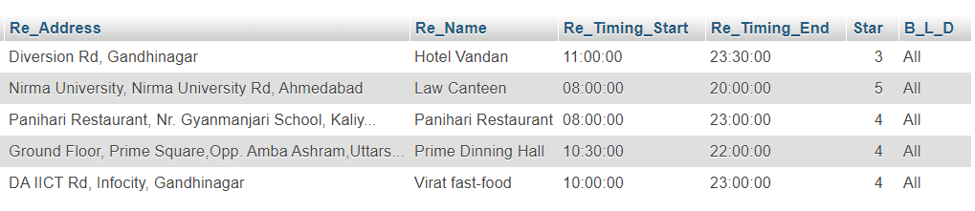

1. **COMMUNITY**

INSERT INTO `community`(`Mentor_Name`, `Community_Head`, `Community_Name`) VALUES ('Harsh Raval', 'Dhrumil Shah', 'Drama Kids');

INSERT INTO `community`(`Mentor_Name`, `Community_Head`, `Community_Name`) VALUES ('Devarshi Sathiya', 'Dhrumit Patel', 'Coder Gang');

INSERT INTO `community`(`Mentor_Name`, `Community_Head`, `Community_Name`) VALUES ('Priyank Shah', 'Raghavendra Gohil', 'DDU Connet');

INSERT INTO `community`(`Mentor_Name`, `Community_Head`, `Community_Name`) VALUES ('Krutik Bhatt', 'Archit Italiya', 'Photo Rider');

INSERT INTO `community`(`Mentor_Name`, `Community_Head`, `Community_Name`) VALUES ('Jay Lakhani', 'Jay Mangukia', 'DSC');

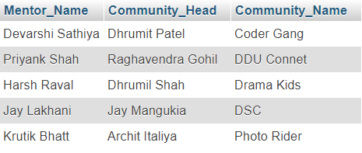

1. **pg_hotel**

INSERT INTO `pg_hostel` VALUES ('Royal Care','Canal Rd, Nadiad', 1407, 'Canal Rd, Nadiad', 02686544552, '100000/year' , 'Yes','3 Sharing','Both','Yes','Boys');

INSERT INTO `pg_hostel` VALUES ('Aarav Hostel','Canal Rd, Bhavnagar', 7, 'Canal Rd, Bhavnagar', 02686544557, '74500/year' , 'Yes','3 Sharing','Both','Yes','Both');

INSERT INTO `pg_hostel` VALUES ('Blossom','ITC centre, Anna Salai, Gandhinagar', 17, 'ITC centre, Anna Salai, Gandhinagar', 02686544570, '50000/year' , 'Yes','2 Sharing','Both','Yes','Girl');

INSERT INTO `pg_hostel` VALUES ('Samaras','Kalavad Road, Gandhinagar', 14, 'Kalavad Road, Gandhinagar', 02686544100, '25000/year' , 'Yes','3 Sharing','Both','Yes','Girls');

INSERT INTO `pg_hostel` VALUES ('Shakti','Nehru road, Ahemdabad', 1407, 'Nehru road, Ahemdabad', 02686545555, '50000/year' , 'Yes','3 Sharing','Both','Yes','Boys');

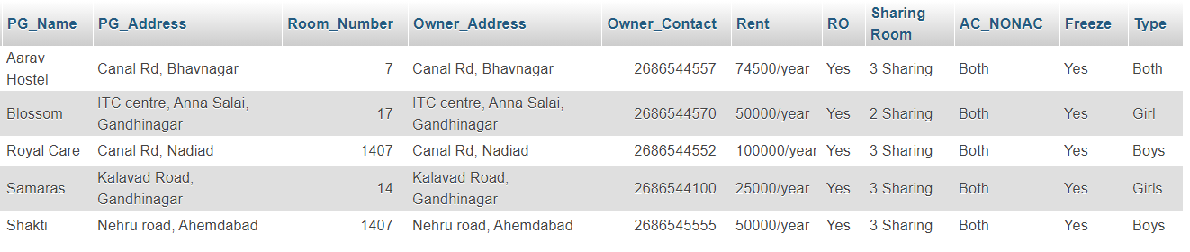

1. **Activity**

INSERT INTO `activity`(`S_ID`, `activity_Name`, `Activity_Place`, `Instruments`) VALUES ('1','Cricket','J&J Ground','');

INSERT INTO `activity`(`S_ID`, `activity_Name`, `Activity_Place`, `Instruments`) VALUES ('2','Badminton','Aloka Sports','Sitar');

INSERT INTO `activity`(`S_ID`, `activity_Name`, `Activity_Place`, `Instruments`) VALUES ('3','Football','AKA Arena','Guitar');

INSERT INTO `activity`(`S_ID`, `activity_Name`, `Activity_Place`, `Instruments`) VALUES ('4','BasketBall','Baketball COurt','');

INSERT INTO `activity`(`S_ID`, `activity_Name`, `Activity_Place`, `Instruments`) VALUES ('5','Music','RK Music','All');

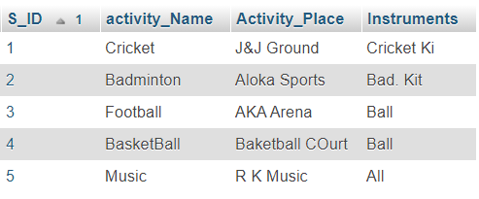

1. **Stationay_buy**

INSERT INTO `stationary_buy`(`S_ID`, `stationary_Name`) VALUES (‘1’,’Student Bo’);

INSERT INTO `stationary_buy`(`S_ID`, `stationary_Name`) VALUES (‘2’, ‘Jay Book’);

INSERT INTO `stationary_buy`(`S_ID`, `stationary_Name`) VALUES (‘3’,’Mahajan’);

INSERT INTO `stationary_buy`(`S_ID`, `stationary_Name`) VALUES (‘4’,’Samir’);

INSERT INTO `stationary_buy`(`S_ID`, `stationary_Name`) VALUES (‘5’,’Vidhyarthi’);

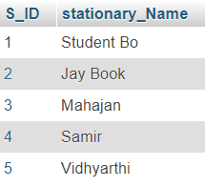

1. **Member**

CREATE TABLE member (S_ID VARCHAR(10),community_Name VARCHAR(25));

ALTER TABLE `member` ADD CONSTRAINT `m2` FOREIGN KEY (`S_ID`) REFERENCES `student` (`S_ID`);

ALTER TABLE `member` ADD CONSTRAINT `m3` FOREIGN KEY (`community_Name`) REFERENCES `community` (`community_Name`);

INSERT INTO `member`(`S_ID`, `community_Name`) VALUES ('1','Drama Kids');

INSERT INTO `member`(`S_ID`, `community_Name`) VALUES ('2','Coder Gang');

INSERT INTO `member`(`S_ID`, `community_Name`) VALUES ('3','DDU Connet');

INSERT INTO `member`(`S_ID`, `community_Name`) VALUES ('4','Photo Rider');

INSERT INTO `member`(`S_ID`, `community_Name`) VALUES ('5','DSC');

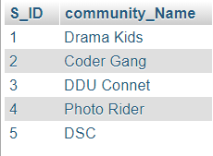

1. **Organize**

INSERT INTO `member`(`S_ID`, `Event_Name`) VALUES ('1','BreakUp Day');

INSERT INTO `member`(`S_ID`, `Event_Name`) VALUES ('2','Coding war');

INSERT INTO `member`(`S_ID`, `Event_Name`) VALUES ('3','Cycle Marathon');

INSERT INTO `member`(`S_ID`, `Event_Name`) VALUES ('4','Falicicfic');

INSERT INTO `member`(`S_ID`, `Event_Name`) VALUES ('5','Photography');

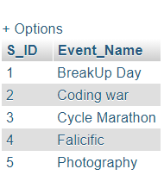

1. **Admin**

INSERT INTO `admin`(`UserName`, `Password`, `S_ID`, `PG_Name`, `Re_Name`, `Event_Name`, `University_Name`, `Book_ID`, `community_Name`, `activity_Name`, `stationary_Name`) VALUES ('Admin', 'admin1','1','Aarav Hostel','Prime Dinning Hall','BreakUp day','Dharmsinh Desai','1','Drama Kids','Cricket','Student Bo');

INSERT INTO `admin`(`UserName`, `Password`, `S_ID`, `PG_Name`, `Re_Name`, `Event_Name`, `University_Name`, `Book_ID`, `community_Name`, `activity_Name`, `stationary_Name`) VALUES ('Admin1', 'admin1','2','Blossom','Hotel Vandan','Coding war','IIT-Gandhinagar','2','Coder Gang','Badminton','Jay Book');

INSERT INTO `admin`(`UserName`, `Password`, `S_ID`, `PG_Name`, `Re_Name`, `Event_Name`, `University_Name`, `Book_ID`, `community_Name`, `activity_Name`, `stationary_Name`) VALUES ('Admin2', 'admin1','3','Shakti','Law Canteen','Cycle Marathon','Nirma','3','DDU Connet','Football','Mahajan');

INSERT INTO `admin`(`UserName`, `Password`, `S_ID`, `PG_Name`, `Re_Name`, `Event_Name`, `University_Name`, `Book_ID`, `community_Name`, `activity_Name`, `stationary_Name`) VALUES ('Admin3', 'admin1','4','Aarav Hostel','Panihari Restaurant','Falicific','GMIT','4','Photo rider','Basketball','Samir');

INSERT INTO `admin`(`UserName`, `Password`, `S_ID`, `PG_Name`, `Re_Name`, `Event_Name`, `University_Name`, `Book_ID`, `community_Name`, `activity_Name`, `stationary_Name`) VALUES ('Admin4', 'admin1','5','Samaras','Virat fast-food','Photography','DaIICT','5','DSC','Music','Vidhyarthi');

